**Kanban For Planet Group**

1. Actors
2. General Manager
3. Hiring Manager
4. HR Department
5. Applicants
6. Activities

**General Manager:** General Manager is the one who manages the resources in the firm by hiring new employees or removing additional employees. General Manager send a request to the HR Manager regarding the requirements.

**Hiring Manager:** Hiring Manager is the one who make certain steps before hiring new employees by creating job descriptions, administering skills alignment etc.

**HR Department:** HR is the one who hires new employees after the order from Hiring Manager based on certain tests to the applicants and interviews. The role of HR is to hire new employees or retain the people the organization needs to execute its strategy and achieve its goals.

**Applicants:** Applicants area the one who are completing their education and waiting for the jobs. They apply for the jobs and appear for the test that a particular firm carry.

1. **Workflow of Activities**

A Hiring Manager submits a hiring requisition to the HR Department

The request contains the following information:

Customer details

Requisition number

Date of request

Requester

Date position available

Job title

Job description

Job level

Number of direct reports

Division

Department

Salary to offer

Bonus amount

Hiring manager comments

New position

If the answer to “New position” is Yes, the request is forwarded to a General Manager.

After the General Manager receives the request, the General Manager indicates approval or disapproval.

1. If the request is not approved, the General Manager specifies a reason, and the request is closed. If the request is approved, a salary compliance check is conducted.
2. The Hiring Manager is notified of the General Manager’s decision immediately after the General Manager approval step.
3. After the requisition is submitted, an automated system checks for salary compliance. If the request meets salary compliance, the hiring request is automatically posted to the HR Positions database and made available for dissemination.
4. When a request violates the established salary guidelines of the company, the HR Administrator can approve or reject the requested salary override.
5. If the salary override is approved, the request is posted to the HR Positions database and made available for dissemination.
6. If the HR Administrator rejects the requested salary, the HR Administrator must provide comments for the violation, add a proposed salary, and send the request back to the Hiring Manager who originated the request.
7. When the Hiring Manager gets the request back because of a rejection, the Hiring Manager can negotiate an adjusted salary or can cancel the request. If the negotiation is successful, the request is resubmitted back to the same HR Administrator.
8. All hiring requests must be added to the HR Positions database regardless of the disposition at the end of the process during a finalization activity.
9. The HR Administrator has 4 hours to complete the review.
10. If the review is not completed within 4 hours, an email is sent to the HR Administrator. The email notifies the HR Administrator of the missed deadline.
11. **Connect the defined activities on a flow from start to end**

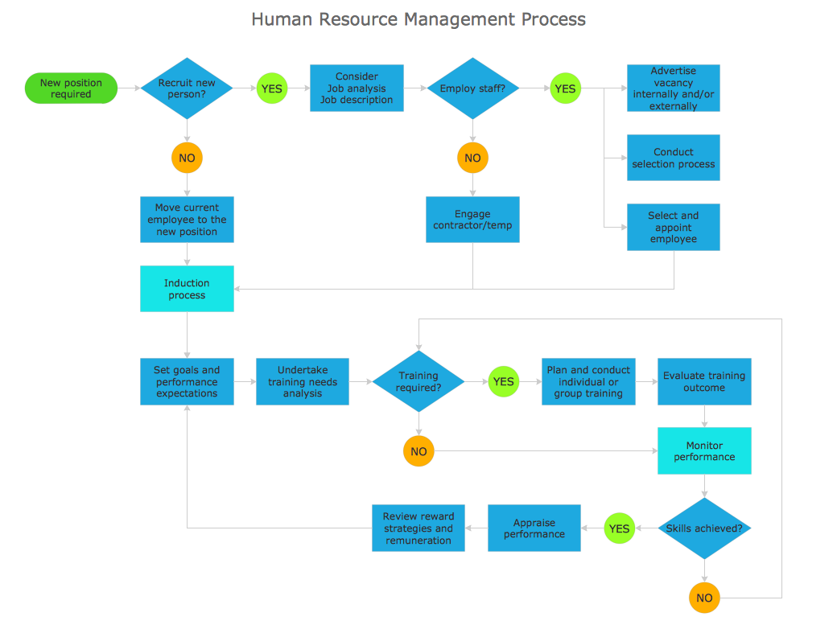

|  |  |  |  |
| --- | --- | --- | --- |
| Role | Task | Time Required | Accept |
| Hiring Manager | Comments on New Role | 5 hours | Pass to general manager |
| General Manager | Take Decision based on the performance | 4 hours | If accept, then make salary negotiations else specify a reason and request to close. |
| System Check | If the request meets salary compliance, the hiring request is automatically posted to the HR positions database. | 4 hours | If the request violates the HR approve or reject the requested salary. |
| Hiring Manager | The hiring request in database must be reviewed | 4 hours | If review is not complete, then an email is sent to HR administrator about missing deadline. |
| General Manager | After the review HR Manager send the list to the General manager. | 5 hours | The General Manager approves the list. |